**MCM301 - Fall 2022.**

**ASSIGNMENT # 01.**

Name: Abdul Rehman.

VU ID: BC220424444.

**Solution:**

* **Anger**.

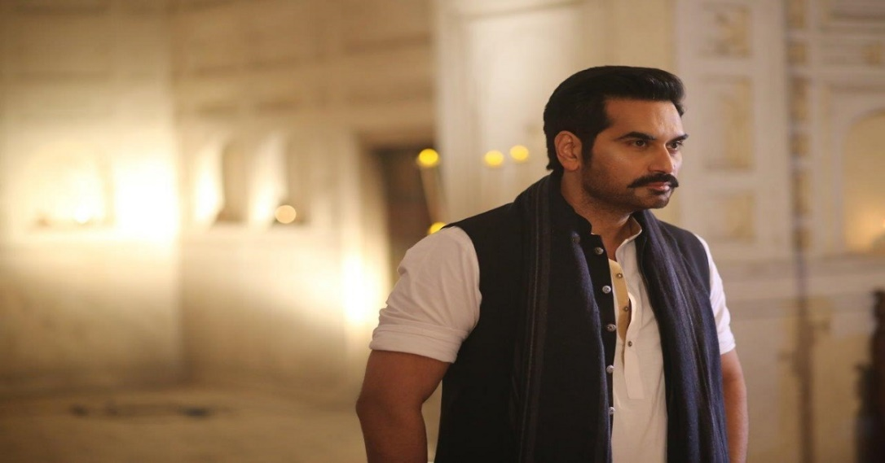

* **Sadness**.

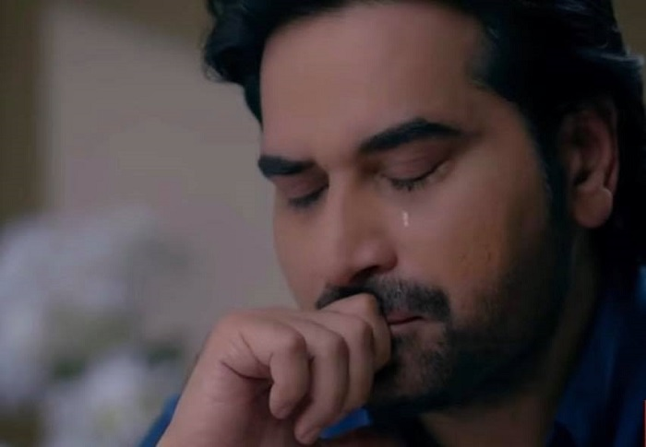

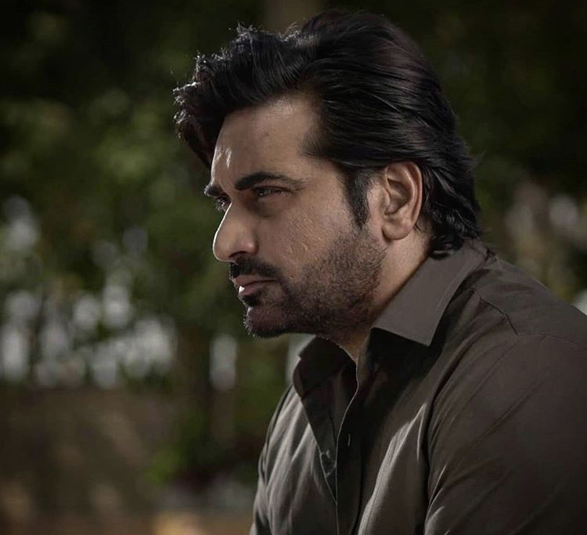

* **Excited.**

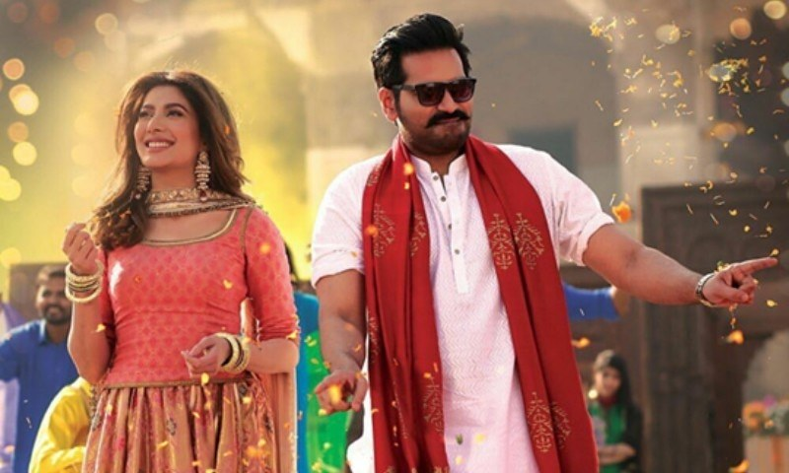

* **Happy**

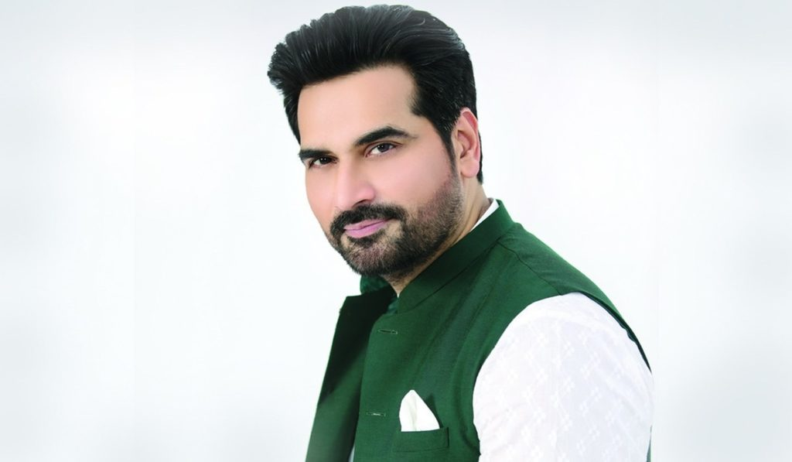

* **Thoughtful.**

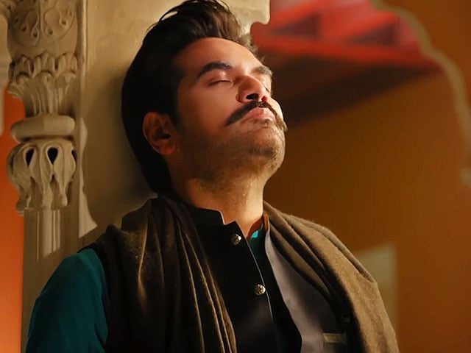

* **Confused**.

